Microservices Task
1.Forked the Repo to my Githup
2. Cloned to Local machine
3. Created Dockerfile
FROM node:18-alpine
WORKDIR /app
COPY package*.json ./
RUN npm install
COPY . .
EXPOSE 3000
CMD ["node", "app.js"]

4. Created Docker-compose.yaml file for building the Dockers
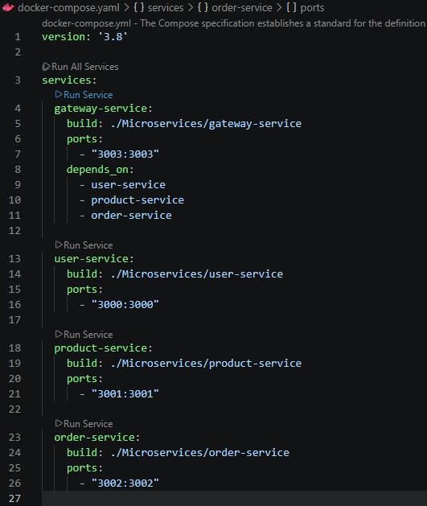
5. Dockers Created
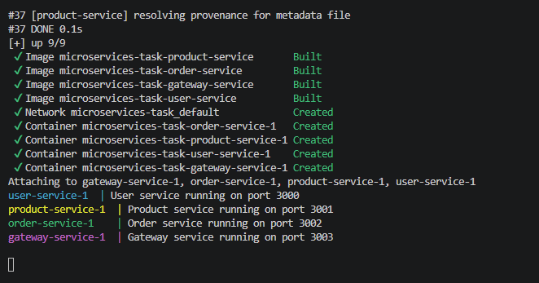
6. In Docker Desktop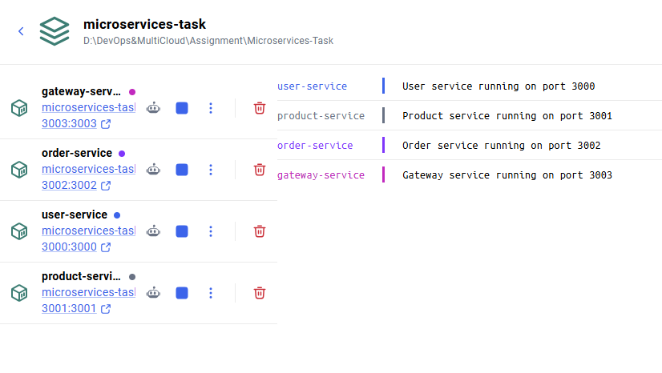
Results:
